Table 1. Hierarchical classification of Cannabis
Kingdom | Plantae
Unranked clade | Anthophyta (Angiospermae)
Unranked clade | Eudicot
Order | Rosales
Family | Cannabaceae
Genus | Cannabis
Species | Cannabis sativa, Cannabis sativa sub. indica var. afghanica (“Indica”), Cannabis sativa sub. indica var. Indica (“Sativa”), Cannabis sativa sub. ruderalis (“Ruderalis”), Cannabis sativa sub. indica var. himalayensis, Cannabis sativa sub. indica var. asperrima
Common Name | Marijuana, pot, bhang, ganja, tea, mary jane, mota, electric/devils lettuce, dagga, má, wacky tobacco, weed, herb, chronic, hydro...

Table 2.1. Hierarchical classification of 3 domains of life.
Domain | Kingdom | Members
Bacteria | Bacteria | Actinobacteria (Actinomycetota), Proteobacteria (Pseudomonadota), Cyanobacteria (Cyanophyta), Spirochaete (Spirochaetota), ect.
Archaea | Archaea | Extremophiles, methanogens
Eukaryota | Excavata | Various flagellate protozoa
 | Amoebozoa | Most lobose amoeboids and slime molds
 | Opisthokonta | Animals, fungi, choanoflagellates
 | Rhizaria | Radiolaria, and various other amoeboid protozoa
 | Chromalveolata | Stramenopiles (Brown Algae, Diatoms etc.), Haptophyta, Cryptophyta (or cryptomonads), and Alveolata
 | Archaeplastida | Land plants, green algae, red algae, and glaucophytes

Table 5.1. Hierarchical classification of some commonly encountered fungi
Kingdom | Fungi | Fungi | Fungi | Fungi | Fungi
Phylum | Basidiomycota | Mucoromycota | Mucoromycota | Ascomycota | Ascomycota
Subphylum |  | Glomeromycotina | Mucoromycotina
Class | Hymenomycetes | Glomeromycetes | Incertae sedis | Sordariomycetes | Leotiomycetes
Order | Agaricales | Glomerales | Incertae sedis | Hypocreales | Helotiales
Family | Agaricaceae | Glomeraceae | Incertae sedis | Hypocreaceae | Sclerotiniaceae
Genus | Agaricus | Glomus | Planticonsortium | Trichoderma | Botrytis
Species | Agaricus bisporus | Glomus  mosseae | tenue  mosseae | Trichoderma  viride | Botrytis  cinerea
Common Name | portabello, crimini, button mushroom | arbuscular mycorrhiza,  endomycorrhiza | Mycormycotina fine root endophytes | Green mold | Grey mold, bud rot

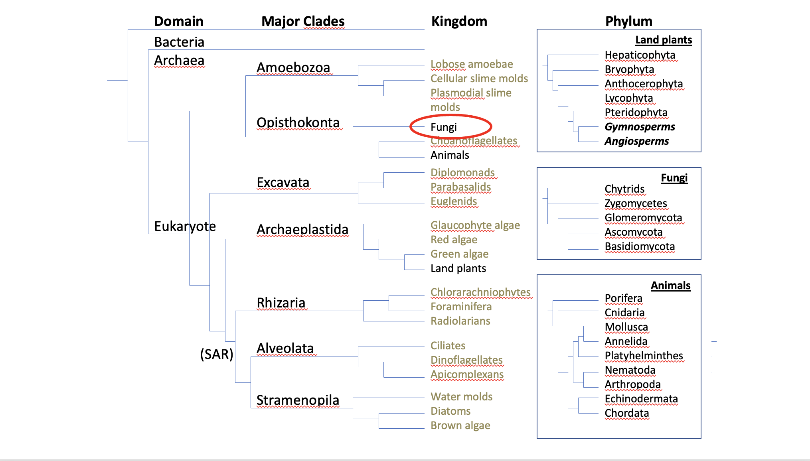

Figure 5.1. Example of a basic tree of life.

Table 3. Hierarchical classification of Arbuscular Mycorrhizal Fungi (Walker et al 2018)
Kingdom | Fungi
Phylum | Mucoromycota | Mucoromycota
Subphylum | Glomeromycotina | Mucoromycotina
Class | Archaeosporomycetes, Glomeromycetes, and Paraglomeromycetes | Mucoromycetes
Order | Archaeosporales, Diversisporales, Gigasporales, Glomerales and Paraglomerales | Endogonales, Mucorales  (Incertae sedis)
Family | Glomeraceae, Gigasporaceae, etc. | Endogonaceae  (Incertae sedis)
Genus | Glomus, Gigaspora, Funneliformis, Rhizophagus, ect. | Planticonsortium
Species | Funneliformis mosseae, Rhizophagus intraradices, ect. | Planticonsortium tenue (Synonym, Glomus tenue)

Powdery Mildew
Kingdom: | Fungi
Phylum: | Ascomycota
Class: | Leotiomycetes
Order: | Erysiphales
Family: | Erysiphaceae
Genus: | Golovinomyces; Podospheara ; Leveillula
Species:  unresolved | Golovinomyces ambrosiae (Syn. G. cichoracearum, G. spadiceus); Podosphera macularis (formerly Sphaerotheca macularis); Leveillula taurica;

Bud Rot
Kingdom: | Fungi | Fungi | Fungi | Fungi | Fungi
Phylum: | Ascomycota | Ascomycota | Ascomycota | Ascomycota | Ascomycota
Class: | Leotiomycetes | Leotiomycetes | Sordariomycetes | Sordariomycetes | Eurotiomycetes
Order: | Helotiales | Helotiales | Hypocreales | Diaporthales | Eurotiales
Family: | Sclerotiniaceae | Sclerotiniaceae | Nectriaceae | Diaporthaceae | Trichocomaceae
Genus: | Botrytis | Sclerotinia | Fusarium | Diaporthe | Aspergillus
Species: | B. cinerea,*  B. pseudocinerea, B. porri | S. sclerotiorum | F. graminearum | D. eres | A. flavus, A. niger, A. terrus, A ostianus, A. fumigatus, ect.
* Botrytis cineria, by far the most common casual organism of budrot, is the asexual stage (anamorph) of Botryotinia fuckeliana. Botryotinia fuckeliana is the corresponding name for the sexual stage (teleomorph) of the same species of fungus. Such duplicate names are the result from the historical develoment of taxonomy, when the sexual and asexual stages of the same species were thought to be different. This fungus is referred to by its anamorph (asexual) name, because the sexual state (Botryotinia fuckeliana) is rarely seen.

Damping Off

Kingdom: | Fungi | Fungi | Fungi | Chromista | Fungi
Phylum: | Basidiomycota | Ascomycota | Ascomycota | Heterokontophyta | Ascomycota
Class: | Agaricomycetes | Leotiomycetes | Sordariomycetes | Oomycota | Dothideomycetes
Order: | Cantharellales | Helotiales | Hypocreales | Peronosporales | Botryosphaeriales
Family: | Ceratobasidiaceae | Sclerotiniaceae | Nectriaceae | Pythiaceae | Botryosphaeriaceae
Genus: | Rhizoctonia | Botrytis | Fusarium | Pythium | Macrophomina
Species: | R. solani | cinerea | F. solani, F. oxysporum, F. sulphurem, F. avenaceum, F. graminearum. | P. aphanidermatum, P. ultimum, P. myriotylym  Globosporangium irreguare | M. phaseolina

Vascular Wilts
Kingdom: | Fungi | Fungi | Fungi | Fungi | Fungi | Fungi
Phylum: | Ascomycota | Ascomycota | Ascomycota | Basidiomycota | Ascomycota | Ascomycota
Class: | Sordariomycetes | Sordariomycetes | Dothideomycetes | Agaricomycetes | Pezizomycetes | Sordariomycetes
Order: | Hypocreales | Hypocreales | Botryoshaeriales | Atheliales | Pezizales | Xylariales
Family: | Nectriaceae | unresolved | Botryosphaeriaceae | Atheliales | Rhizinaceae | Xylariaceae
Genus: | Fusarium | Verticillium | Macrophomina | Sclerotium | Phymatotrichopsis | Dematophora
Species: | F. solani, F. oxysporum, F. sulphurem, F. avenaceum, F. graminearum., F. proliferatum,  F. brachygibbossum | V. dahliae, V. albo-atrum | M. phaseolina | S. rolfsii, S. minor | P. omnivora | D. nectrix

Hemp Canker

Kingdom: | Fungi | Fungi | Fungi | Fungi | Fungi
Phylum: | Ascomycota | Ascomycota | Ascomycota | Ascomycota | Ascomycota
Class: | Leotiomycetes | Dothideomycetes | Dothideomycetes | Dothideomycetes | Sordariomycetes
Order: | Helotiales | Pleosporomycetidae | Pleosporomycetidae | Capnodiales | Hypocreales
Family: | Sclerotiniaceae | Didymellaceae | Didymellaceae | Davidiellaceae | Nectriaceae
Genus: | Sclerotinia | Phoma | Ascochyta | Cladosporium | Fusarium
Species: | S. sclerotiorum & S. minor | P. cannabis, P. exigua, P. glomerata, P. herbarum, P. piskorzii, P. nebulosa | A. cannabina, A. arcuata | C. herbarum, C. resinae, C. tenuissiumum, C. cladosporioides | F. sulphureum, F. avenaceum, F. sulphurem, F. graminearum.

Leaf Spot
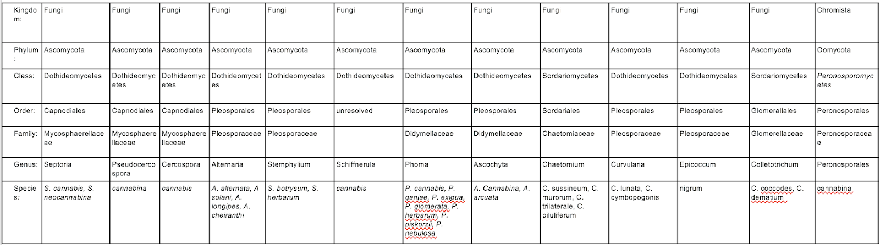

Post Harvest Rot Fungi
Table 18.1 A partial list of post harvest fungi that affect Cannabis. All of these may cause losses due to rot and spore contamination. Some pose human health threats as producers of mycotoxins or as direct human pathogens.
Kingdom: | Fungi | Fungi | Fungi | Fungi | Fungi
Phylum: | Ascomycota | Ascomycota | Ascomycota | Ascomycota | Mucoromycotina
Class: | Leotiomycetes | Eurotiomycetes | Eurotiomycetes | Sordariomycetes | Zygomycetes
Order: | Helotiales | Eurotiales | Eurotiales | Hypocreales | Mucorales
Family: | Sclerotiniaceae | Trichocomaceae | Trichocomaceae | Nectriaceae | Mucoraceae
Genus: | Botrytis | Aspergillus | Penicillium | Fusarium | Rhizopus
Species: | Botrytis cinerea | Aspergillus flavus, A. niger, | Penicillium citrinum, P. paxilli, P. commune, P. copticola | Fusarium oxysporum,  F. solani, F. equiseti | Rhizopus stolonifer

